FXJ-5050Z AUTO FOLD
CARTON SEALING MACHINE

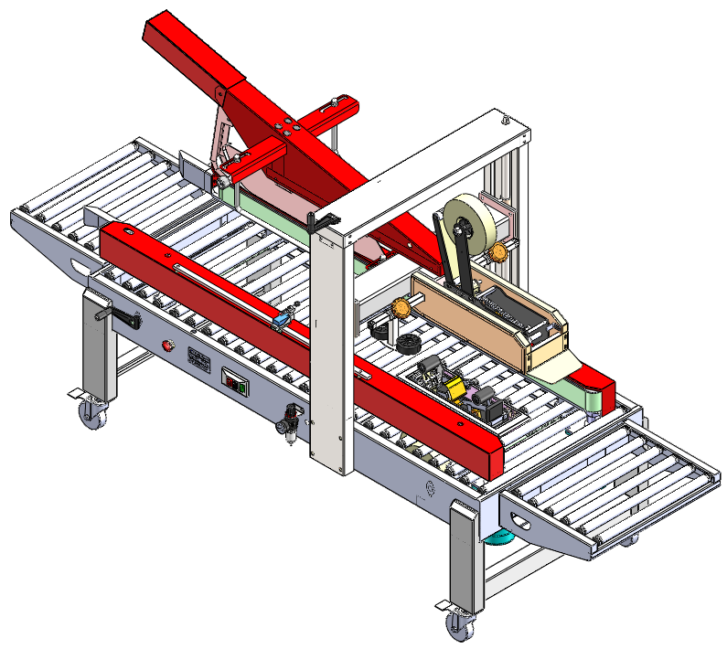

CONTENT

I.Application

II.Main specification

III.Machine structure & Spare parts explosive view

IV.Operation process

V.Fault & solution

VI. Maintaining

VII.Electric circuit diagram

VIII.Air diagram

IX.Spare parts along with the machine

I.Application
Automatic fold carton sealing machine suit packing same size cartons, sealing the cartons with stick tape. Artificial positioning when the size of the cartons are changed, the upper cover and back cover folded automatically, flattening don’t fold angle fold into fast. Cover of both side are smooth and beautiful, motors of both side catch the PVC tape automatically and pat, send into and seal cartons. It can finish up and down sealing in one step. This machine adopt pneumatic device achieve back cover fold automatic. It is reliable working, convenient operation and easily maintenance. This machine can be used single and used with automatic strapping machine and conveyor as a automatic sealing & strapping packing line. Stick tape sealing neatly, firm, regular, artistic, without tearing the cartons. This machine is widely used in food, beverage, cosmetics, household appliances, book, textiles…other industries.

II.Main specification
No. | Items | unit | specification
1 | Max packing size(W*H*L) | mm | 500×500×600
2 | Min packing size（W*H*L） | mm | 200×160×200
3 | Conveyor speed | m/min | 18
4 | Table height | mm | 600～800
5 | Width of tape | mm | 48 60 75
6 | Power | -- | AC220V，50Hz， 420W
7 | Air souce | -- | 2/3L， 5Kgf/cm²
8 | Conveyor feeding |  | Two sides feeding
9 | Machine size(L*H*W) | mm | 2680×900×（1480～1680）
10 | Weight | Kg

III.Machine structure & Spare parts explosive view
1、Frame 2、Work table 3、Tapping width adjusting handle
4、Emergency stop 5.Power on/off 6. Up/down adjusting handle
7.Air Source 8.Stand column 9.Left conveyor
10.Right conveyor 11.Down tapping head seat 12.Tapping head
13.Up tapping head seat 14. Carton fix wheel 15. Locking handle
16.Auto Folding parts 17.Limit switch 18.Main specification plate

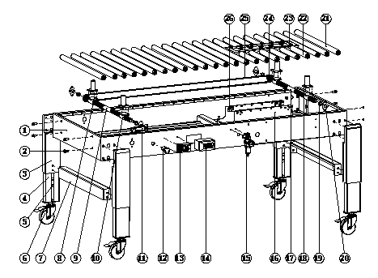

Item | Parts name | Qty | Spefication
1 | Frame | 1
2 | Connected bolt | 8
3 | Footstand | 4
4 | Adjustable foot | 4
5 | Foot adjustable block | 4
6 | Trundle | 4 | 100X30XM14
7 | Support rod | 2
8 | Adjusting screw nut(left rotation) | 2
9 | Driving spindle | 1
10 | Adjusting screw nut(right rotation) | 2
11 | Handle | 1
12 | Emergency stop | 1
13 | Specification plate | 1
14 | Magnetic switch | 1 | PS-211
15 | Pressure adjustor filter | 1 | AFR2000
16 | Down tapping head frame | 1
17 | Driven spindle | 1
18 | Connecting base | 4
19 | Bearing seat sleeve | 4
20 | Bearing seat | 4
21 | Long roller assembly | 18
22 | Short roller assembly | 12
23 | Guide plate | 1
24 | Chain wheel | 2
25 | Chain (296 joint) | 1 | 06B

Item | Parts name | Qty | Spefication
1 | Conveyor table | 1
2 | B type cotter | 2
3 | Roller seal | 12
4 | Roller rod of conveyor | 6
5 | Conveyor roller | 6
6 | Split washer 6 | 12 | GB/T 896-1986
7 | Pressure spring | 6
8 | Flat washer 8 | 12 | GB/T 95-2002

item | Parts name | Qty | Specification
1 | Beam | 1
2 | Supporting seat | 2
3 | deep groove ball bearing 61903 | 2 | GB 276-94
4 | Spring | 2
5 | Upper beam | 1
6 | Column | 2
7 | Locking wheel | 2
8 | Carton fixing wheel seat (left) | 1
9 | Position fixed stick | 1
10 | Cover board | 2
11 | Left frame of upper tape seat | 1
12 | Supporting stick | 1
13 | Leading board | 1
14 | Fasten board | 1
15 | Fixed seat of upper tape seat | 4
16 | Right frame | 1
17 | Front leading board | 1
18 | Stick cover | 2
19 | Carton fixed wheel | 4
20 | Spindle of carton fixed wheel | 4
21 | Right carton fixed wheel seat | 1
22 | V type groove board | 2
23 | Flat bearing seat | 2
24 | Single-direction bearing 51103 | 2
25 | Screw | 2
26 | Lifting nut | 2
27 | Horizontal-Adjusting supproting seat | 1
28 | Folding fixed board | 4
29 | Pin 5*45 | 2 | GB/T 1096-2003
30 | Folding stick | 2
31 | Folding seat | 1
32 | Cylinder fixed seat | 1
33 | Leading wheel | 2
34 | Folding holder | 1
35 | Mini-cylinder | 1 | MAL-CA 32×125-SDB
36 | Connector | 1
37 | Sleeve | 2
38 | Supporting stick A | 1
39 | Bearing | 2 | φ16×φ12×14
40 | Spindle | 1
41 | swinger | 1
42 | Cover | 1
43 | External cover | 1
44 | Sealing botton | 4 | HP-22
45 | Horizontal-adjusting supporting seat | 1
46 | Nut M12 | 4
47 | Flat washer 12 | 4 | GB/T 95-2002
48 | I type nut M12 | 4 | GB/T 41-2000
49 | Chain (181 joint) | 1 | 06B
50 | Driving chain wheel | 2
51 | Handle | 1

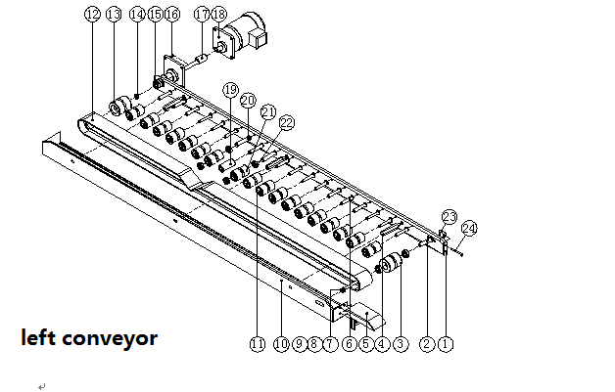
Item | Parts name | Qty | Specification
1 | Left conveyor belt shelf | 1
2 | Passive wheel spindle | 1
3 | Passive wheel | 1
4 | Fixed rod | 3
5 | Left guiding plate | 1
6 | Shaft of carrier wheel | 16
7 | Cap screw M10X100 | 1 | GB/T 70.1-2000
8 | Flat gasket 10 | 1 | GB/T 95-2002
9 | Standard spring gasket 10 | 1 | GB/T 93-2002
10 | Left conveyor belt cover | 1
11 | carrier wheel | 16
12 | Conveyor belt | 1 | 5×75×3565
13 | Driving wheel | 1
14 | Sleeve | 1
15 | deep groove ball bearing 6202 | 4 | GB 276-94
16 | Shaft Key 5×45 | 1 | GB/T 1096-2003
17 | Driving wheel spindle | 1
18 | Driving motor | 1 | J220V18-200-15-C
19 | Roller | 1
20 | Shaft of carrier wheel | 3
21 | carrier wheel | 2
22 | deep groove ball bearing 16002 | 4 | GB 276-94
23 | Passive wheel fix block | 1
24 | Hexagon headed bolt M6X60 | 1 | GB/T 5780-2000

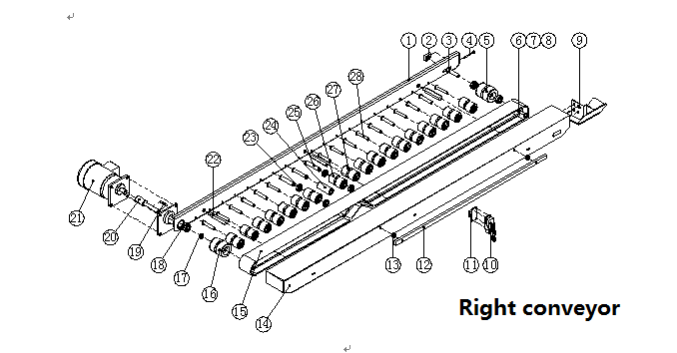
Item | Parts name | Qty | Specification
1 | Right conveyor belt shelf | 1
2 | Passive wheel fix block | 1
3 | Passive wheel spindle | 1
4 | Hexagon headed bolt M6X60 | 1 | GB/T 5780-2000
5 | Passive wheel | 1
6 | Cap screw M10X100 | 1 | GB/T 70.1-2000
7 | Flat gasket 10 | 1 | GB/T 95-2002
8 | Standard spring gasket 10 | 1 | GB/T 93-2002
9 | Right guiding plate | 1
10 | Micro-switch | 1
11 | Micro switch seat | 1
12 | Micro switch fix rod | 1
13 | Sleeve | 2
14 | Right conveyor belt cover | 1
15 | Conveyor belt | 1 | 5×75×3565
16 | Driving wheel | 1
17 | Sleeve | 1
18 | deep groove ball bearing 6202 | 4 | GB 276-94
19 | Shaft Key 5×45 | 1 | GB/T 1096-2003
20 | Driving wheel spindle | 1
21 | Driving motor | 1 | J220V18-200-15-C
22 | Fixed rod | 3
23 | deep groove ball bearing 16002 | 4 | GB 276-94
24 | Roller | 1
25 | Shaft of carrier wheel | 3
26 | carrier wheel | 2
27 | carrier wheel | 16
28 | Shaft of carrier wheel | 16

Item | Parts name | Qty | Spefication
1 | Left plate | 1
2 | Beam locking screw | 2
3 | Beam sleeve | 2
4 | Stiffener | 1
5 | Adjusting plate | 1
6 | Connecting stick of cutter | 1
7 | Bearing φ16xφ20x12 | 4
8 | Driving plate of rubber wheelⅠ | 1
9 | Bearing φ10xφ14x10 | 2
10 | Cover of cutter restⅠ | 1
11 | Driving spindle of rubber wheel connecting stickⅡ | 1
12 | Cover of cutterⅡ | 1
13 | Spindle of rubber wheel | 2
14 | Center of rubber wheelⅡ | 1
15 | External of rubber wheel | 2
16 | Center of rubber wheelⅠ | 3
17 | Fixed clamp of brusher | 1
18 | Brusher | 1
19 | Cutting knife | 1
20 | Fixed plate of cutter | 1
21 | Compression spring shaft | 2
22 | Compressed spring of wheel | 2
23 | Pressing wheel shaft | 1
24 | Guide cover of pressed wheel A | 1
25 | Supporting seat of pressed wheel | 1
26 | Spring of knurl wheel | 1
27 | Knurl wheel shaft | 1
28 | Cutter cover shaft | 1
29 | Guide cover of pressed wheel B | 1
30 | Right plate | 1
31 | Right plate | 1
32 | Clip ring 8 | 1 | GB 894.1-86
33 | Small knurl wheel | 1
34 | Pressed spring of big knurl wheel | 2
35 | Cutter shaft | 1
36 | Driving spindle of rubber wheel connecting rodⅠ | 1
37 | Big knurl wheel | 1
38 | Carton press plate | 1
39 | Pressed wheel | 1
40 | Supporting shaft of pressed wheel | 2
41 | Clip ring 10 | 4 | GB 894.1-86
42 | One-way bearing | 1 | HF1616-6HJ
43 | RollerⅠ | 1
44 | Tension spring | 1
45 | Big knurl wheel shaft | 1
46 | Clip ring 16 | 3 | GB 894.1-86
47 | Shaft | 1
48 | Driving plate of rubber wheel II | 1
49 | Tension spring of rubber roller (down) | 1
50 | Supporting rod | 1
51 | Fixed block of cutting knife | 1
52 | Tension adjusting knob | 1
53 | Pressure spring of tape roller | 1
54 | Friction sleeve | 1
55 | Tape fixed roller | 1
56 | Roller Ⅱ | 1
57 | Cover of tape | 1
58 | Connecting sleeve | 1
59 | Roller shaftⅡ | 1
60 | Tape roller shaft | 1
61 | Roller l | 1
62 | supporting seat of tape | 1
63 | Connecting rod of rubber wheel | 1
64 | Fixed pin of connecting rod | 1
65 | Bearing φ16xφ20x20 | 1
66 | Round pin φ5X24 | 2 | GB/T 879.1-2000
67 | Spacing board | 1
68 | Cap screw M6X16 | 4 | GB/T 70.1-2000

IV. Operation process
IV1. Preparing
1）Place the machine on the level ground; check the agility of all moving parts and see if there is anything stuck; check machine if there is any tightened parts are loose. Adjust and correct it if there is any problem.
2）The machine working environment should be no corrosive gas
3）Lock the caster and adjust the legs in appropriate height for working or be level to the production line.

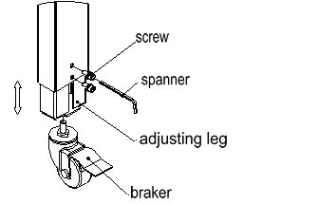

IV2.Mchine adjustment
- Tape put diagram：install put on tape roller, adhesive side towards up, through roller II, roller I, big knurl wheel, small knurl wheel, press wheel seat and rubber wheel.
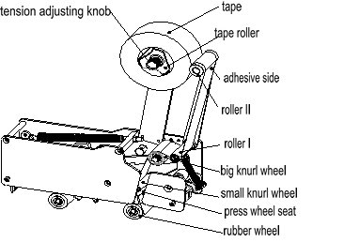
- Tape tension adjusting: adjust knob to adjust tension of tape, rotary it clockwisely tension will be more, conversely will be less
- Sealing length of 2 sides tape adjusting: adjust position of cutter to reach it, front long/rear short, loosen M5 screw of cutter and move cutter forth, then tighten M5 screw, front short/rear long, adjust it conversely
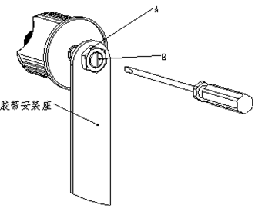
- Adjust tape position: loosen nut, use straight type screw driver adjust shaft to make tape at center position

5). Air source settle（see diagram 5）
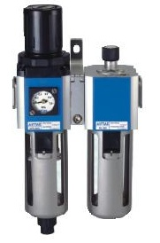
Adjust button
Adjust loop

Pressure gage

Manual dewatering
Button

5).1 Please clean the connect pipe and contactor when install it，avoid dirty objects getting into gas circuit.
5).2 When install it, please ensure the gas flow direction is the same to
the direction of arrows on diad point, connecting pipes and contactor is
correct.
5).3 Water exhause（filter）
Water is drained into the cup by push up the exhause button, prohibit
draining water without the filters. The water must be drained out before water level arrive position of down filter element seat。
5).4 Pressure adjustment（adjust valve）
Please pull up the pressure adjust button before rotating it, press down adjust button is fixed. Clockwise rotate the button is heighten pressure, anticlockwise is opposed. When adjust the pressure, should adjust it even and step by step to the correct number, normally it is 4KGf/ cm², don’t adjust it at once.

Machine operation：
1）Put the carton required to be packed on the conveyor table：
A、Adjust the height of upper tape seat unit with height-adjusting handle , make it to be 3-5 mm lower than carton
B、loosen locking handle, adjust fixed stick to make them fixed carton, then tight it
C、loosend locking wheel, adjust fixed wheels to close to cartons, then tight locking wheel
2）Make sure to input right power source and air source 4Kgf/cm as they are required. Switch on machine and conveyor motors start running. Put carton on conveyor table and push in. Carton will be transmitted through and be folding automatically and sealed top & bottom with tape at the same time. When carton goes out tape seat unit, cutting knife will jump out and cut off tape.

V.Fault & solution
NO. | Faults | Reason | Solution
1 | Can’t cut tape | Cutter is blunt | Replace or wash cutter
2 | Tape after cutting is not tidy | Cutter isn’t installed correctly, there is no enough tension on spring of cutter | Check screws on cutter if loosen or not  add some lubricating oil on spring
3 | tape doesn’t attach on carton tightly | Roller rotary with tape together after long time working | Add lubricating oil on roller
4 | Carton gets block | Nut of tape roller is too tighten, carton height desn’t adjust well  Spring is too tighten | Loosen nut  Adjust height  Loosen spring
5 | Tape break during sealing | Cutter protude too much | Adjust cutter
6 | Tape moves when sealing | Pressure of 2 sides press wheel is different | Adjust press wheels
7 | There is noise when sealing | Bearing is dirty | Wash and add lubricating oil
8 | Tape attach too lossen | Spring on sealing seat is loosen  Tape sealing lose frication | Add spring tension  Adjust frication

VI. Maintenance
6.1 keep machine dry and clean
6.2 don’t put dirty or wet objects on machine
6.3 washing cutter and add lubricating oil before using
6.4 add lubricating oil on driving parts every 2 months
6.5 check all screws and nut every 2 months
6.6 carton requirements
6.6.1cartons must keep dry
6.6.2 there is no dirt on carton surface
6.6.3 transformative cartons can’t be sealed
6.6.4 sides of carton should be tidy
6.7 tape requirements
6.7.1 center transformative can’t be used
6.7.2 coil transformative can’t be used
6.7.3 paper tape can’t be used
6.7.4 widtha and thickness are not uniform can be used
6.7.5 there is scratch on surface can’t be used
6.7.6 don’t use tape after manufacturing more than half year

VII.Electric circuit diagram
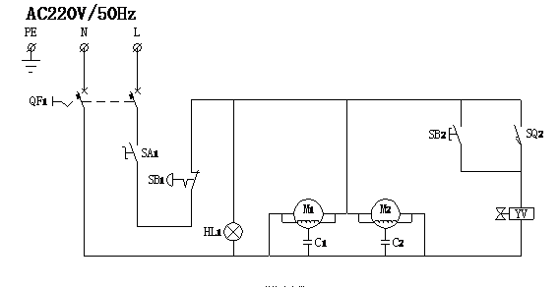

VIII.Air diagram
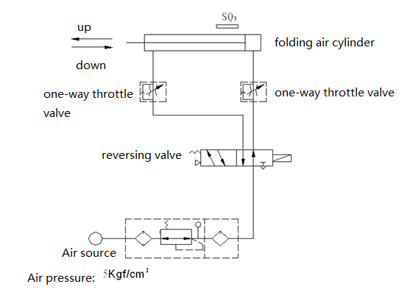

IX. Spare parts along with the machine

Item | Name | Qty
1 | FXJ5050Z operation manual | 1
2 | Small tool box | 1
3 | Allen wrench （M3/M4/M5/M6/M8/M10） | Each 1
4 | Scross screw driver(4”) | 1
5 | Straight screw driver 6*150mm | 1
6 | Handle | 1
7 | Fuse(φ10*38/10A） | 2
8 | Open spanner 8-10 | 1
9 | Open spanner 12-14 | 1
10 | Open spanner 19-22 | 1
11 | Brusher | 1
12 | Roller spring(φ10.5*20) | 1
13 | Pressure spring(φ14*20) | 1
14 | Air pipe | 1

